Temasek Polytechnic
School of Informatics & IT
Diploma in Financial Business Informatics

AY2011/2012 Oct Semester Level 3
MP Terms of Reference

Project Particulars

Supervisor | Esther Chia
Project ID | FBI1215
Project Title | nTrader

Project Team’s Particulars

Group Name | SOLY
Matric Number | Student Name
1003346B | Soh Jun Jie
1001423A | Leung Kai Yiu
1004142D | Ong Qi Yong
1001433J | Yan Dawei

1. Introduction

Project nTrader aim is to build a web service solution for retail investors or simply people who want to understand financial news, and be able to make trading decisions base on the news.
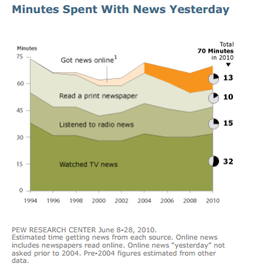
With the increase in digital news from both internet and mobile platforms, people are spending much more time in news consumption, with time devoted to digital news increasing steadily and time spent on less mobile print newspaper declining, since 1994 (PEW, 2010).

In terms of time-effective trading decisions, Project nTrader will helps its users by giving bull or bear signals about investments mentioned in the financial news.

Base on the theory that the market will incorporate all market news into stock prices, we also see the opportunity for automatic trading base on financial news before human public can assess its impact.

Project nTrader also aims to remove the technicalities of financial jargons in financial news by simplifying jargons to layman’s terms.

2. Objectives of the Project

Project outcome

To create a system which aims to aid investors who do not have the luxury of time to read financial news articles by providing them with geographical market sentiments (bullish, bearish or neutral) from Bloomberg news.

System Objectives

The web application of Project nTrader will be able to:

- Analyze financial news article’s headline from Bloomberg latest or archive news to generate bull-bear signal
- Translate financial jargons in financial news article to understandable terms
- Perform news filtering on the financial news extracted by the web application
- Allow user(s) to add/update the keywords database to reduce database maintenance

Learning Objectives

- Learn and investigate the correlation between financial news and the behavior of the stock market
- Learn and investigate the type of algorithms and models use by industry players to process natural language and their application
- Learn how to design and build a technological infrastructure geared towards news analytics
- Learn the history of Financial news and their providers
- Learn how to use industry standard Amazon EC2 server
- Learn common types of financial jargons used in the financial industry

Applying Taught Subjects to Project

- Database Information System (DBIS): Apply the logic of structuring a relational database, perform data modeling for database scalability, and data maintenance
- Web Programming (WebP): Apply PHP language used in WebP project to create webpages and news analysis algorithm logic
- Information Systems and Office Fundamentals (ISOFun) & Derivatives and Structure Products Processing (DSP): Apply VBA skills learnt by creating Ad-Hoc programs to improve group productivity, learn how news affect prices of financial instruments
- IT Project Management (ITPM): Apply project management skills learn to manage the lifecycle of the project and team members
- Introduction to Human-Computer Interaction (iHCI): Apply user interface concepts taught to create user-friendly webpages
- Business Intelligence System (BIS): Opportunity to apply data analytics using map chart dashboard to analyze geographical market sentiment
- Fundamental of Investment (FOI): Apply and integrate knowledge in financial keywords learnt with financial keywords in Investopedia’s knowledge base
- Student Internship Programme (SIP): Apply knowledge and skills learn in internship programme i.e. Industry standards and coding practices, Regular Expression, project management skills, communication skills

3. Scope of the Project

The following points will be part of Project nTrader’s scope:

- Setup Web Infrastructure and Testing Platform
  - Net Beans Integrated Development Environment
  - Amazon Web services
- Setup Centralized Project Repository
  - Dropbox cloud storage
- Project Documentations
  - Project Schedule with activities
  - Weekly Progress update
  - Weekly Individual Journal
  - Major Project Report
- Database Maintenance (on-going process)
  - Collect relevant keywords, synonyms and financial jargons from financial news articles and dictionary.
  - Database will be built and constantly configured in a scalable and dynamic manner in order to take into account future expansions, a smoother future maintenance process and the data organization structure’s flexibility for analytical purposes.
- Algorithms
  - Extraction logic to retrieve financial news article from Bloomberg website where the news article’s headline have the word “stocks” as part of it
  - Text analytical logic to generate bull and bear signal for the retrieved financial news article
  - Logic to extract different variation of a word such as verb conjugations, synonyms and different tenses
  - Text analytical logic to transform financial jargons from news article into terms readable by a novice investor
  - Algorithms Flow Chart/Tree Diagram
- Web and User Interface Design
  - Webpage navigation flowchart
  - Webpage user interface draft templates on adobe Photoshop

The following will not be part of Project nTrader’s scope in the 10 weeks MP period and will be considered as add-on features if any are included:

- API coding to allow third party trading systems to establish connection with web application
  - Performing automatic trading by generated bull-bear signals from financial news
  - Bull-bear signal SMS Notification for specified products, financial news, etc
- Business Intelligence Map chart showing macro geographical view of country/region market sentiment using archived bull-bear financial news indicator data
- In-depth analysis of any financial news article main content to identify key economic indicators and keywords that causes financial instrument price movement

4. Constraints

- Time constraints: 10 weeks
- Money constraints: no sponsor
- Skill constraints: limited to certain programming language
- Manpower constraints: only 4 personnel, shortage of linguists and programmers verse in Natural Language Processing Algorithms
- Technological constraints: Internet speed and blocking of certain ports

5. Resources

 | Item
Hardware | Amazon Elastic Compute Cloud  - With built-in Apache, PHP APC, MySQL and TomCat6  Laptops and computer machine
Software | Adobe Photoshop CS5  Adobe Dreamweaver CS6  Amazon Web Services Management Console  Dropbox  FileZilla  Microsoft Office 2010  Microsoft Office Visio  Microsoft Project  MySQL Query Browser  NotePad  phpMyAdmin  Xampp

6. Anticipated Problems and Contingency Plans

The development of Project nTrader exists in the Amazon EC2 server. The project also relies on news feed from Bloomberg to provide value and perform various functions that are core to the web application. There will be problems if nTrader’s dependencies fail to perform as expected by the web application.

Bloomberg website failure

Project nTrader is dependent on Bloomberg primarily on the news feed provided publicly by it. nTrader uses financial news located in Bloomberg main website to generate value, for example, creating bull-bear signal, financial jargons simplification, and in-depth news analysis. In the event of Bloomberg website downtime, we ensure the continued operations of our web application by archiving historical Bloomberg news on a daily basis. Thus the web solution will display the archived financial news instead of entering into downtime along with Bloomberg.

As another alternative for the future, we will also diversify and expand providers of financial news to our data feed. For example, including Reuters news to nTrader’s project scope. This dependency in 2 or more financial news providers will allow us to protect the web application from news providers’ downtime risk, and at the same time get the most current news whichever news provider can provide the fastest.

Amazon EC2 server failure

As our web application is intended to run on Amazon EC2 server, failure on the part of Amazon EC2 server will result in our web application downtime. As of current, we can tackle this problem by immediately switching to another server instance if the current server instance experience downtime, or switching to another sever provider if Amazon EC2 services are no longer reliable.

From the future perspective, we will adopt Apache Hadoop implementation for the nTrader web application. This means that the web application will be supported by multiple server instances instead of only one server which is the current situation. Using this implementation will improve performance as more servers are used to support the web application. Being supported by multiple servers, the web application will also experience lesser probability of downtime.

Internal to the nTrader project, we anticipated problems such as failed programming algorithm, insufficient development time and accidental loss of project files or data.

Failed programming algorithm

In the event the programming algorithm for creating bull-bear signal base on financial news fails, the project team can focus their capability on the second functionality of the web application – financial jargons simplification and context translation. The project team will research on other programming algorithm used by industry players to minimize failure rate of the algorithm.

In the event the financial jargons simplification algorithm also fails to materialize, the team will use their skill sets to analyze financial reports which will be of a consistent format and can also provide a certain degree of predictability to stock prices.

Insufficient development time

With the project team ambitious plan to build a comprehensive full-functional news analytics web application, 10 weeks’ time period may be a challenge. The team will consider perform scope reduction on the type of news to be analyzed, the extent which the financial news articles can be analyzed, and whether to implement map chart dashboard BI (Business Intelligence) capabilities if necessary.

Accidental loss of project files or data

To protect against the accidental loss of project files and data, the team uses cloud storage Dropbox as first level backup of project files. Project files are also stored in the Amazon EC2 server which forms the second level of files backup. The third level of backup is through each project member’s local copy of the project files. The loss of project files of any one member can thus be retrieved easily through these three levels of backup location.

7. Planned Schedule

WORK BREAKDOWN STRUCTURE

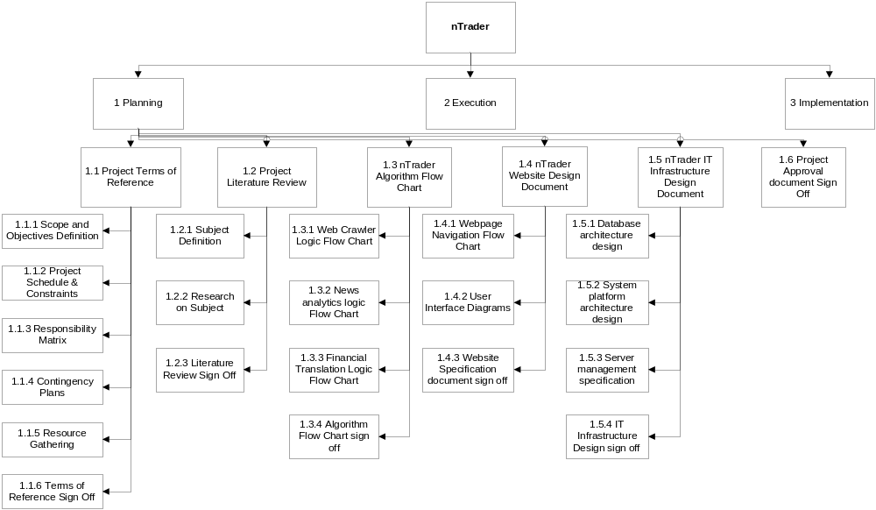
Figure 1: Work Breakdown Structure-1
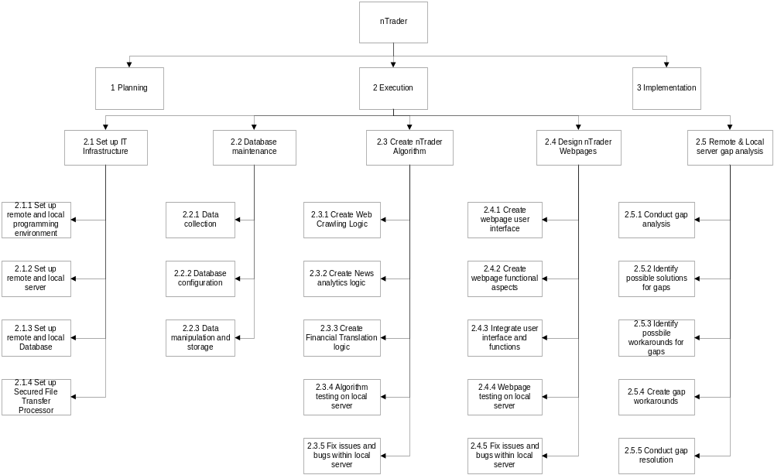

Figure 2: Work Breakdown Structure-2

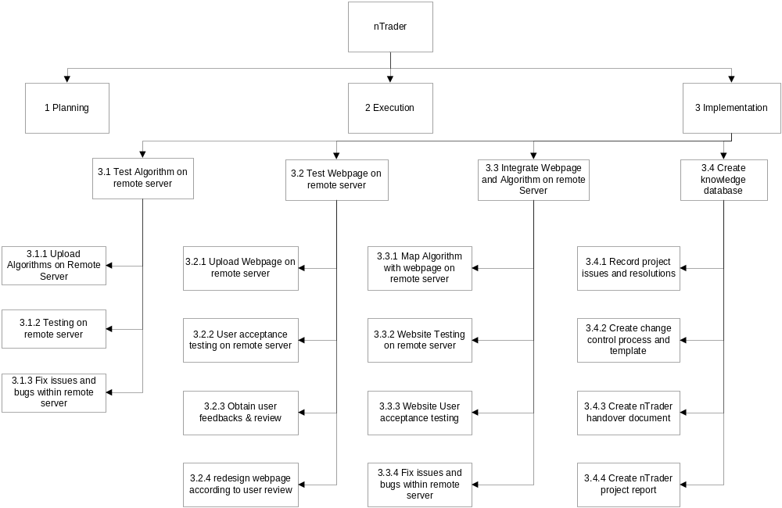

Figure 3: Work Breakdown Structure-3

Bibliography

PEW. (2010, September 12). Americans spending more time following the news. Retrieved 11 15, 2012, from http://www.people-press.org/files/legacy-pdf/652.pdf

